**PYTHON CALCULATOR**:

The following is the output of python calculator program.

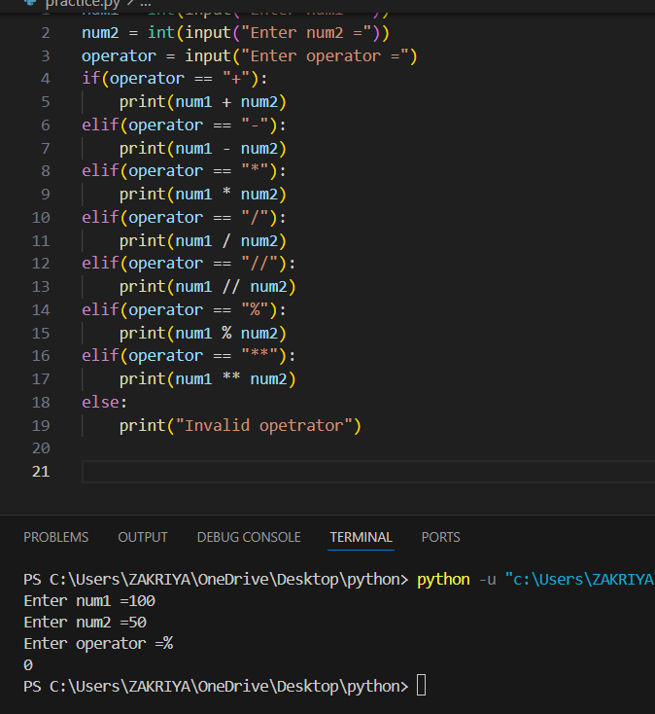

**ASSEMBLY CALCULATOR:**

The following is the output of assembly calculator program.

